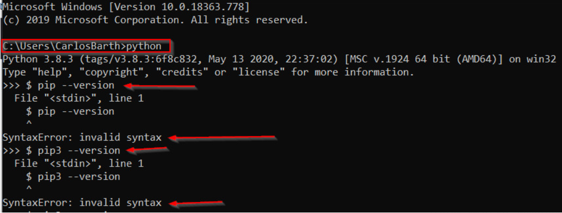

Removed the $ sign and it worked.

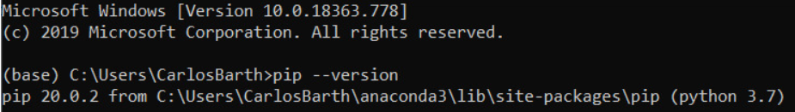

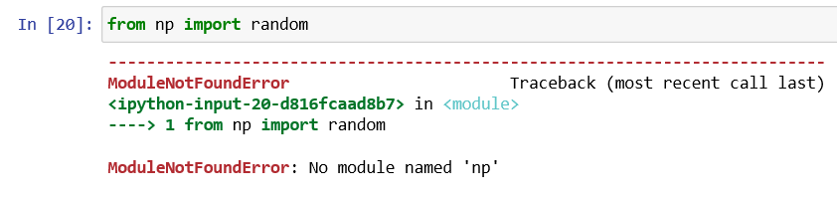

I didn’t import **numpy**



In this case I’m still trying to solve above error message.

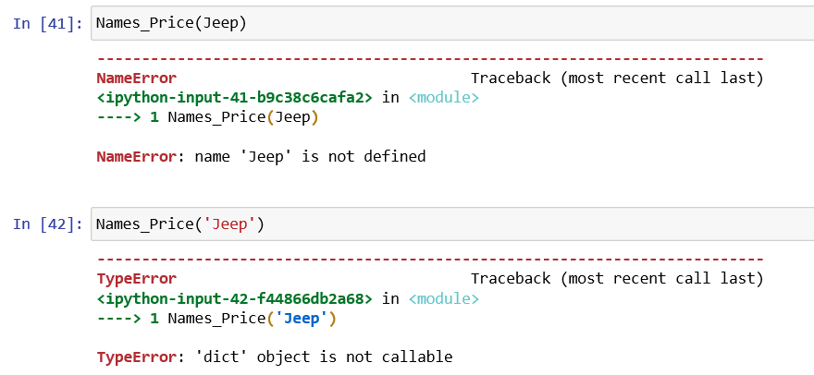

Changed values for dictionary to INT and it worked.

